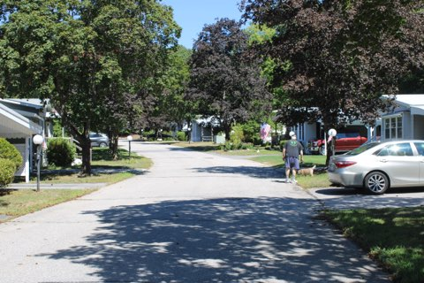
Enter co-op description here
Enter Co-op Name Here
Welcome

Meet the Board of Directors

Board Position | Name
President | Name
Vice President | Name
Treasurer | Name
Operations Manager | Name
Secretary | Name

Rules & Bylaws

Rules

Park Rules are established to maintain safety, community aesthetics, and financial stability, making sure of a high quality of life for resident members.

Bylaws

Bylaws are the foundational legal documents governing the operations, structure, and management of a resident-owned community (ROC). They dictate how the board of directors is elected, how meetings are conducted, and the rights and responsibilities of members. Bylaws make sure the cooperative runs in a fair, democratic, and consistent manner.

We are here to answer questions! If you have questions about our rules and bylaws, please contact the board of directors.

Complaints

If you need to file a complaint, please use the contact:
Add contact for complaints
Complaints can be made anonymously by checking a box on the complaint form.

Get Involved!

Our community is cooperatively run, and we rely on all members to take an active role. We encourage all members to attend board meetings, join committees, volunteer, and stay involved in strengthening our community.

When we meet…
Add when and where meetings are

Have questions? Contact board of directors…

Add contact information (email or phone) and include the expected time of response they should expect.

Annual Meeting

Our annual meeting is held in | Add Month

You will receive a member packet 10 days prior to the meeting which will inform you of all the information that will be covered at the meeting. This meeting is very important, and all members are expected to attend.

Committees
Members can form together for specific functions. Contact the board for a list of active committees or if you are interested in starting one.

Here are some committees that cooperatives may have: Activities Committee, Rules Committee, Membership Committee, Garden Committee, and more.

Paying Your Rent

Your rent of | $A.DD |  | is due on the | day |  | of each month.
Rent paid by mail should be postmarked by: |  |  |  |  | Add date
Mail to: |  | Add mailing address + attention if applicable testing
To pay your rent online, sign into:
Add information for online pay
If you have trouble paying your rent or other contacted service, you can contact the management company at:
Add name of management company
Phone: | Add phone number for management company
Email: | Add email for management company

Waste & Trash Removal

Community waste and trash services are for household trash only. Dumpsters are not to be used for mattresses, appliances, other large household items, or “clean-outs”. Please contact the board of directors if you have any questions about waste and trash removal.

Add all details of waste and trash removal. Include:
Company pickup? Local transfer stations? Or Dumpsters?
Include what day pickup is
when trash cans should be by the curb and empty cans are to return to lot.
What items to recycle

Dig Safe

If you plan to install a basketball hoop, mailbox, fence or other project that requires digging please make sure to call Dig Safe. It is easy and FREE. This will avoid hitting electric, cable or gas as these can sometimes be only inches below the surface. Call 811 and follow the directions given.

Winter Home Care Checklist

 | Heat tape so pipes don’t freeze
 | Roof rake
 | Shovel
 | Animal-friendly ice melt
 | Hair dryer to defrost frozen pipes
 | Plumber’s phone number
 | Bottled water in case of power outages

Helpful Contacts

Utilities
Power | Add name and phone of power company
Cable | Add name and phone of cable company
Oil | Add name and phone of oil company
Gas/Propane | Add name and phone of gas/propane companies
Local Stores
Groceries | Add name and address of grocery stores
Dept Stores | Add name and address of dept. stores
Gas Stations | Add name and address of gas stations
Laundromat | Add name and address of laundromat
Pharmacies | Add name and address of pharmacies
Restaurants
Add name, address, and phone of restaurant
Add name, address, and phone of restaurant
Add name, address, and phone of restaurant
Add name, address, and phone of restaurant

Stay connected with ROC-NH

Website: communityloanfund.org/roc2roc visit the site to stay updated on resources and events.
Socials: join the ROC-NH Facebook group to collaborate with other ROC residents across NH.

